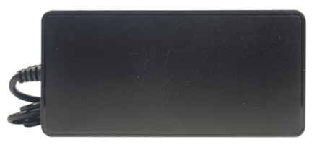

**24V3A Adapter**

FYDS-243(SMPS Adaptor) is designed on Highly Integrated SMPS Switcher IC which makes this product reliable and highly efficient.

* 24V3A Rated Output.
* It comes with 1 mtr wire length and 5.5*2.1mm DC Plug Size.
* Led indicator to show the functional status.
* Made from High grade ABS plastic
* Overload, Over Voltage & Over Current Protection.
* Short Circuit, Over Temperature Protection.
* Unique and attractive design.
* BIS Certified.

**Categories:**[**Desktop Series**](https://www.fyber.co.in/product-category/power-adaptors/desktop-series/)**,**[**Power Adaptors**](https://www.fyber.co.in/product-category/power-adaptors/)

|  |  |  |  |  |  |  |  |  |  |  |  |  |  |  |  |  |  |  |  |  |  |  |  |  |  |  |  |  |  |  |  |  |  |  |  |  |  |  |  |  |  |
| --- | --- | --- | --- | --- | --- | --- | --- | --- | --- | --- | --- | --- | --- | --- | --- | --- | --- | --- | --- | --- | --- | --- | --- | --- | --- | --- | --- | --- | --- | --- | --- | --- | --- | --- | --- | --- | --- | --- | --- | --- | --- |
| |  |  | | --- | --- | | **Feature** | **Specification** | | VAC Voltage | 150~265VAC | | Output voltage | 24VDC | | Rated Power | 72W | | Ripple & Noise (max.) | 70mV(max) | | Voltage Adj. Range | NA | | Device | Primary-Side Regulation CV/CC Switcher for Adapters and Chargers | | Device(frequency) | 85KHz | | VDS Voltage | 600V(max) | | Line Regulations | ±1% | | Load Regulations | ±5% | | SCP | Output short-circuit protection | | ARP | Auto-restart protection reduces power delivered by >90% for output short-circuit and control loop faults (open and shorted components) | | ON/OFF control | ON/OFF control provides constant efficiency down to very light loads – ideal for CEC regulations | | line UV | Line brown-in/out protection | | OV | Line overvoltage shutdown extends line surge withstand | | OTP | Accurate thermal shutdown, hysteretic or latching | | Efficiency(Typ.) | 80% | | Frequency Range | 47~63HZ | | Storage Temperature | 0-50°C |   **For Business Enquiries** |  |
|  |  |
|  |  |
|  |  |
|  |  |
|  |  |
|  |  |
|  |  |
|  |  |
|  |  |
|  |  |
|  |  |
|  |  |
|  |  |
|  |  |
|  |  |
|  |  |
|  |  |
|  |  |
|  |  |

**For Business Enquiries**