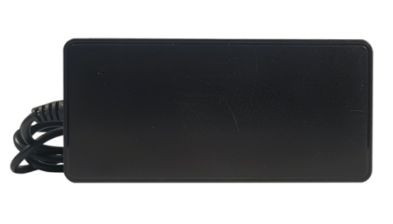

**52V2.5A Adapter**

FYDS-5225(SMPS Adaptor) is designed on Highly Integrated SMPS Switcher IC which makes this product reliable and highly efficient.

* 52V2.5A Rated Output.
* It comes with 1 mtr wire length and 5.5*2.1mm DC Plug Size.
* Led indicator to show the functional status.
* Made from High grade ABS plastic
* Overload, Over Voltage & Over Current Protection.
* Short Circuit, Over Temperature Protection.
* Unique and attractive design.
* BIS Certified.

**Categories:**[**Desktop Series**](https://www.fyber.co.in/product-category/power-adaptors/desktop-series/)**,**[**Power Adaptors**](https://www.fyber.co.in/product-category/power-adaptors/)

|  |  |
| --- | --- |
| **Feature** | **Specification** |
| VAC Voltage | 150~265VAC |
| Output voltage | 52VDC |
| Rated Power | 130W |
| Ripple & Noise (max.) | 70mV(max) |
| Voltage Adj. Range | NA |
| Device | Primary-Side Regulation CV/CC Switcher for Adapters and Chargers |
| Device(frequency) | 85KHz |
| VDS Voltage | 600V(max) |
| Line Regulations | ±1% |
| Load Regulations | ±5% |
| SCP | Output short-circuit protection |
| ARP | Auto-restart protection reduces power delivered by >90% for output short-circuit and control loop faults (open and shorted components) |
| ON/OFF control | ON/OFF control provides constant efficiency down to very light loads – ideal for CEC regulations |
| line UV | Line brown-in/out protection |
| OV | Line overvoltage shutdown extends line surge withstand |
| OTP | Accurate thermal shutdown, hysteretic or latching |
| Efficiency(Typ.) | 80% |
| Frequency Range | 47~63HZ |
| Storage Temperature | 0-50°C |